Final Report
By: Cooper Wang
Team: Formula SAE
Sub-team: Outboard Structures
Sub-team Leader: Andre Chen
Project Leads: Derrick Sun, Matheus Bellizia
I worked on several different projects during the semester, including various research tasks, bond testing, data analysis and calculation, and part designs and drawings. These projects fall under different sub-teams, including control arms, gears, and hubs.
For research, one of the tasks I worked on is the surface processing method of titanium in preparation of using titanium as inserts for the A-arms. I analyzed different techniques such as Plasma Nitriding, Anodizing, and Plasma Electrolytic Processing, and compiled a list of potential service providers that can help with surface processing. I recommended Plasma Electrolytic Processing to Derek, and also gave him recommendations on epoxy options for bonding based on past NASA research. However, the project was later suspended due to issues with the sponsor. 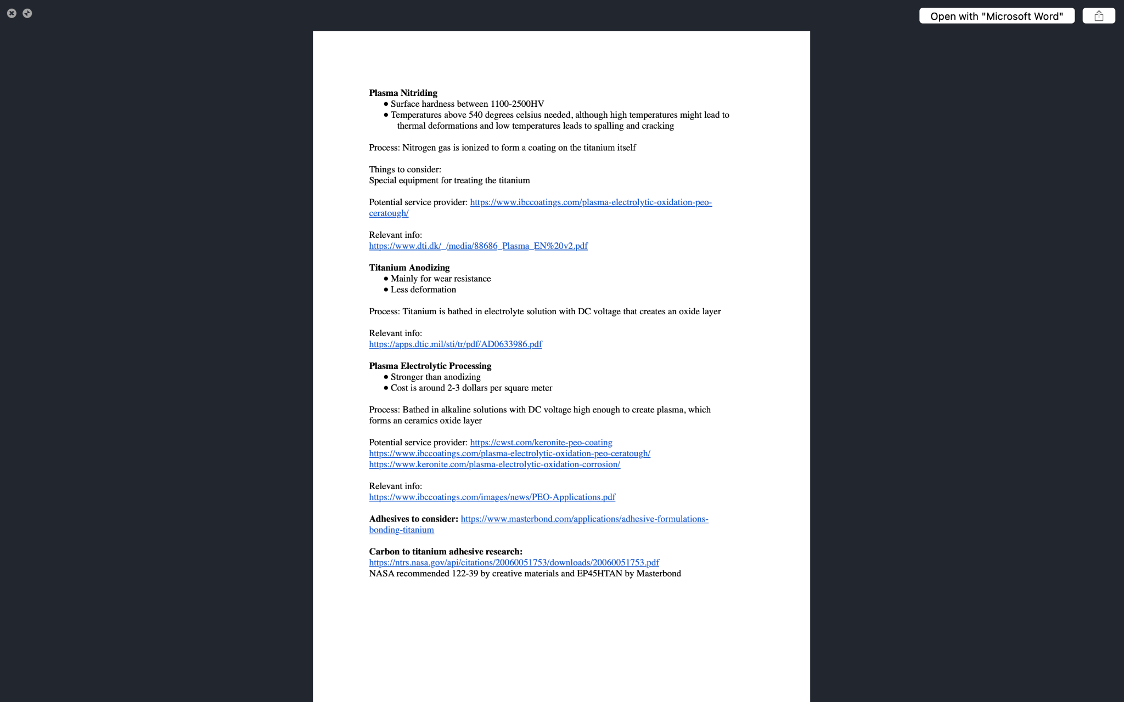
Titanium Surface Processing Report

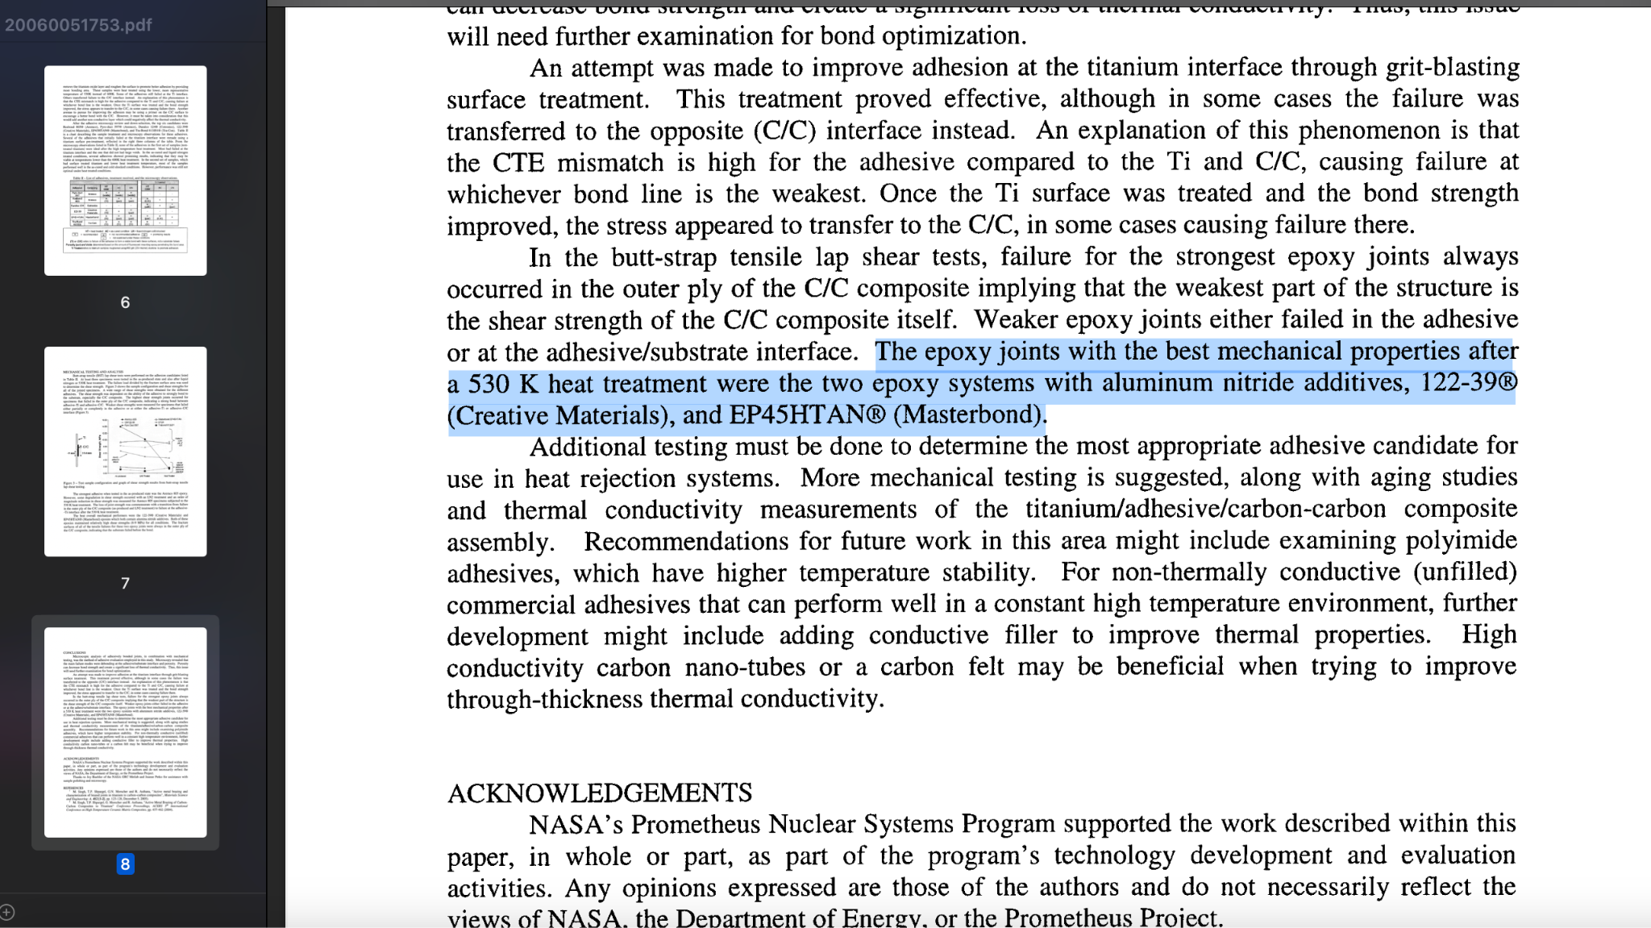
NASA Research on Different Epoxy for Titanium-Carbon Bonding
Another task I worked on for research was finding the correct carbon tubes for the A-arms, which are connected to the vehicle using the inserts. The tubes had to be around the same dimensions compared to the tubes used in previous designs, but should also have higher strength compared to last year in order to have a higher safety factor. I compiled a list of ultra high weave carbon tubes from Rock West Composites and calculated the stiffness, max tension, and max compression based on Young's modulus and various other data given by the manufacturer. When the issue that we might potentially need a tube with higher strength is brought up during the IDR, I also found a thicker tube that is in stock as a back up option for increasing the strength further.
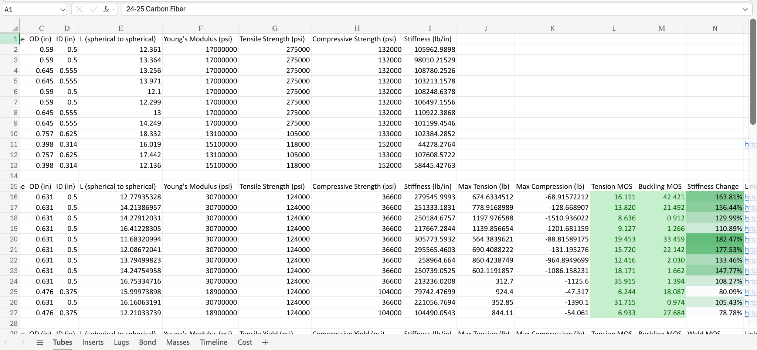
Carbon Tubes Options and Calculations
At last, another research I conducted was the thrust washer and thrust bearing research, which was required for the gears. While the team used simple 3D printed plastic washers in last year’s season, Matheus believed that using new thrust washers or thrust bearings could lead to performance improvements. However, since there are constraints in terms of the available space, the washer and bearing has to be extremely thin and simultaneously have the correct inner and outer diameter to fit on the shaft. At last, the washers and bearings are supposed to handle axial loads instead of perpendicular ones, they are specialized and cannot replaced by conventional bearings, After some research, I compiled a list of potential options and listed out various specifications such as dynamic load, static load, and max RPM for available options.

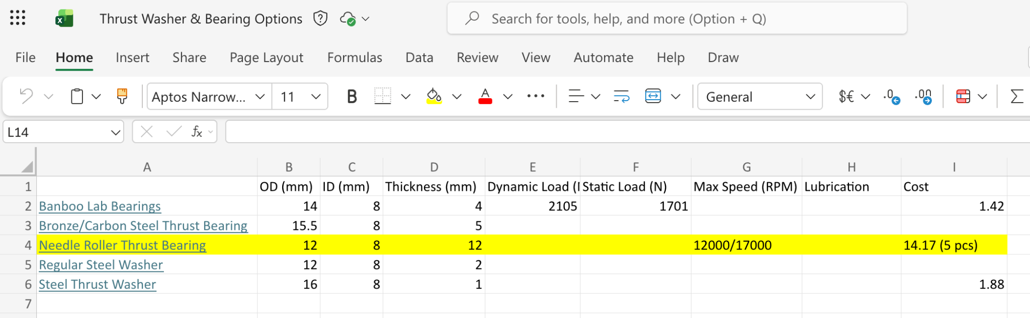
Thrust Bearing and Thrust Washer Options

Meanwhile, I also participated in the bond testing, where we processed the 7075 aluminum inserts by etching them with ten percent sodium hydroxide concentrations, and cleaned them using acetone and IPA. We then cleaned the sanded carbon tubes with IPA, and bonded the inserts with the tubes using epoxy mixed with glass beads. We did multiple sessions of bond testing throughout the semester to test out different techniques and to confirm results. In the first trial, the concentration of sodium hydroxide was incorrect and the time that the insert is supposed to be etched in the procedures description is inaccurate, which resulted in overetched inserts and loose fits with the carbon tubes. Furthermore, while the concentration was corrected in the second trial, the time was still incorrect and resulted in smoother surfaces than expected, resulting in more corrections. The procedures were finally corrected after multiple trials. Before the initial trials, I also helped to fix the sandblaster by replacing the old nozzle with the new one and fixing bad seals using teflon tapes.
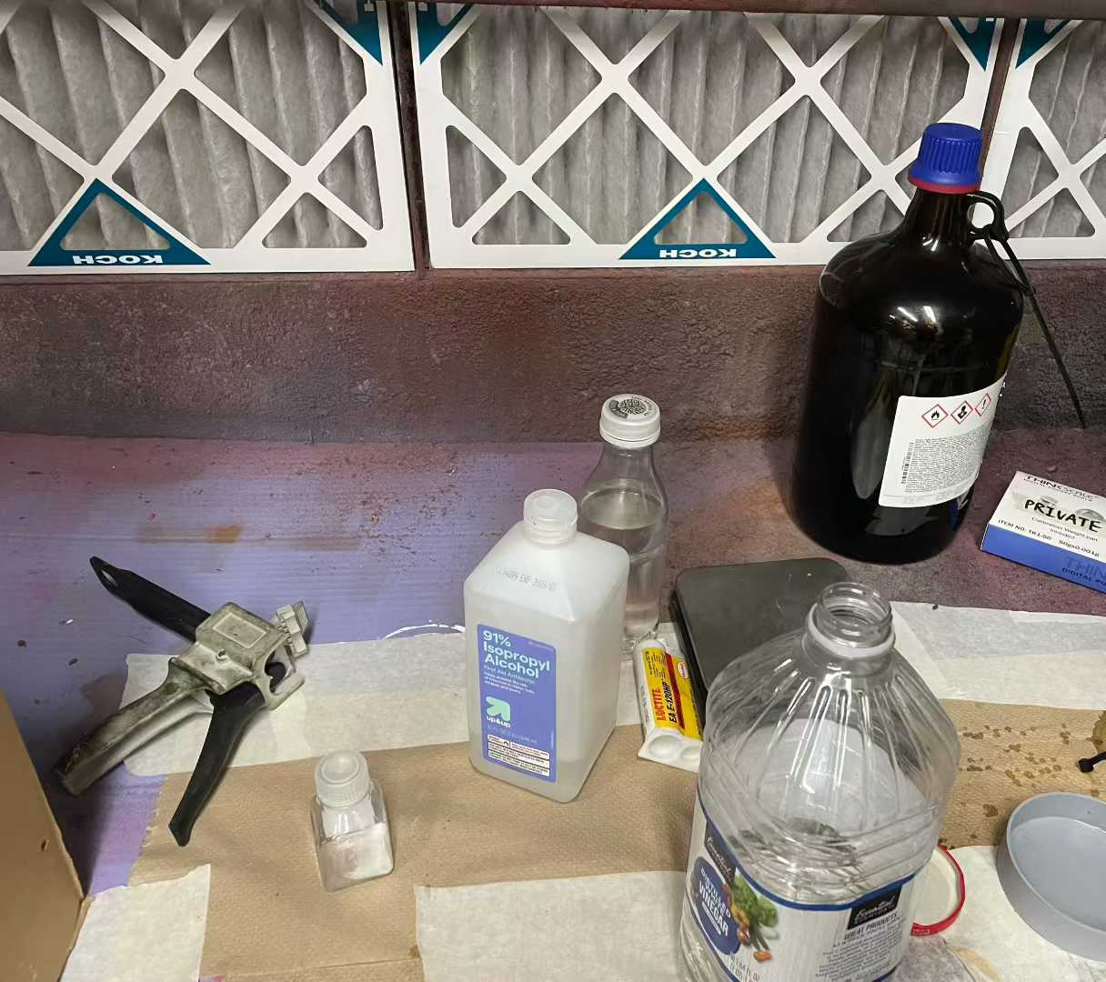
Bonding Setup
Another project I took on was fatigue analysis for the hubs of the vehicle, as the project lead was away right before the design freeze and needed help with calculations. I used the data that contained the moment and the force on the hubs recorded during one of the test sessions, and compiled them using Python. I then approximated the surface area of the hubs based on engineering drawings and calculated the stress based on the estimates. By using Rainflow, a Python library used to calculate fatigue cycles, I recorded the amount of stress cycles the hub experiences and the range of stress in each cycle. I corrected the data using Goodman relation correlation, which makes the calculation more conservative, and looked at the S-N curve of 7075 to determine the amount of fatigue caused by each cycle. At last, I used the Miner’s Rule to add up the amount of fatigue the hub experienced throughout the testing, and accounted for the total runtime of the vehicle to determine the theoretical maximum lifespan of the hubs.
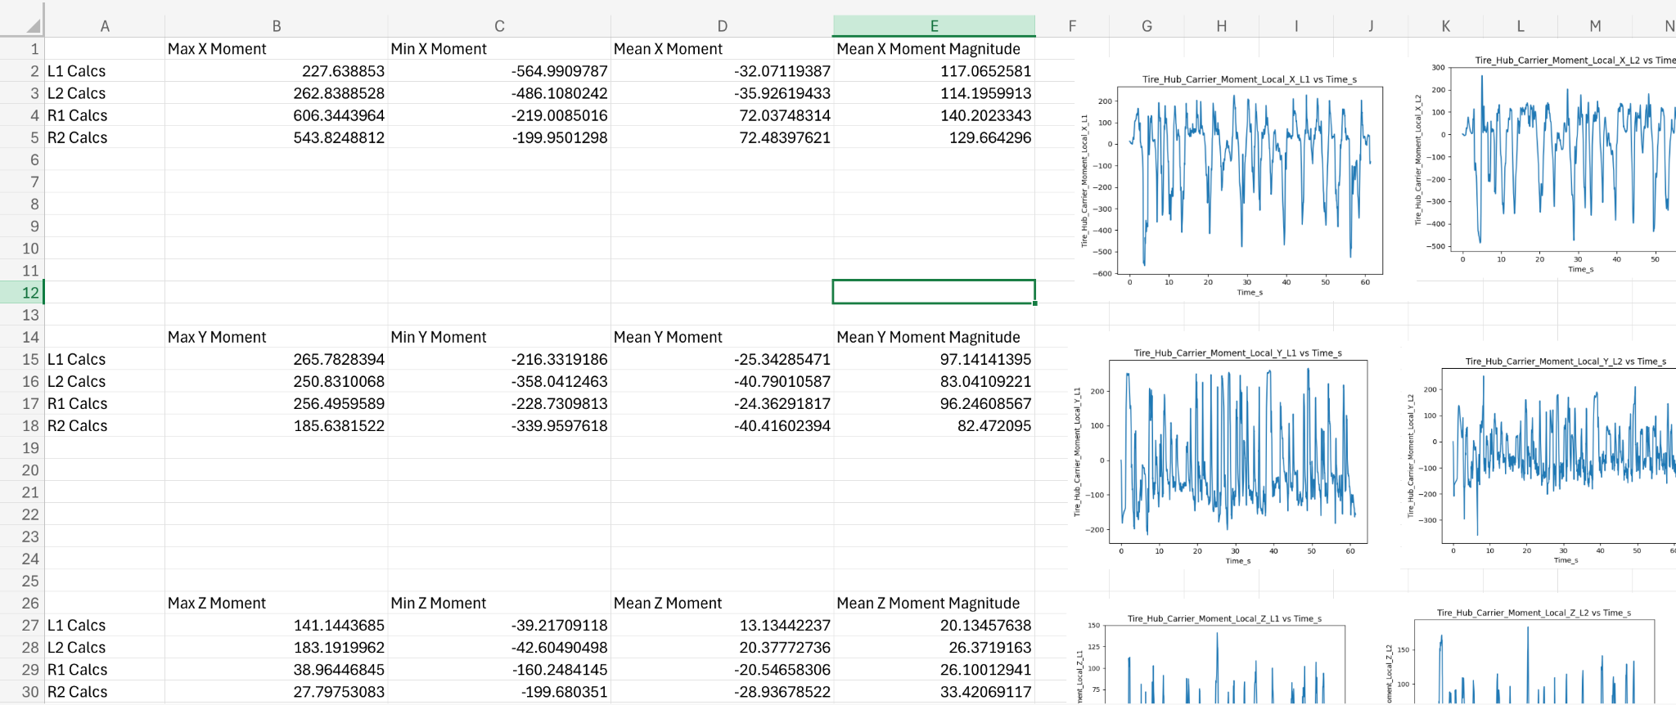
Testing Data Compilation

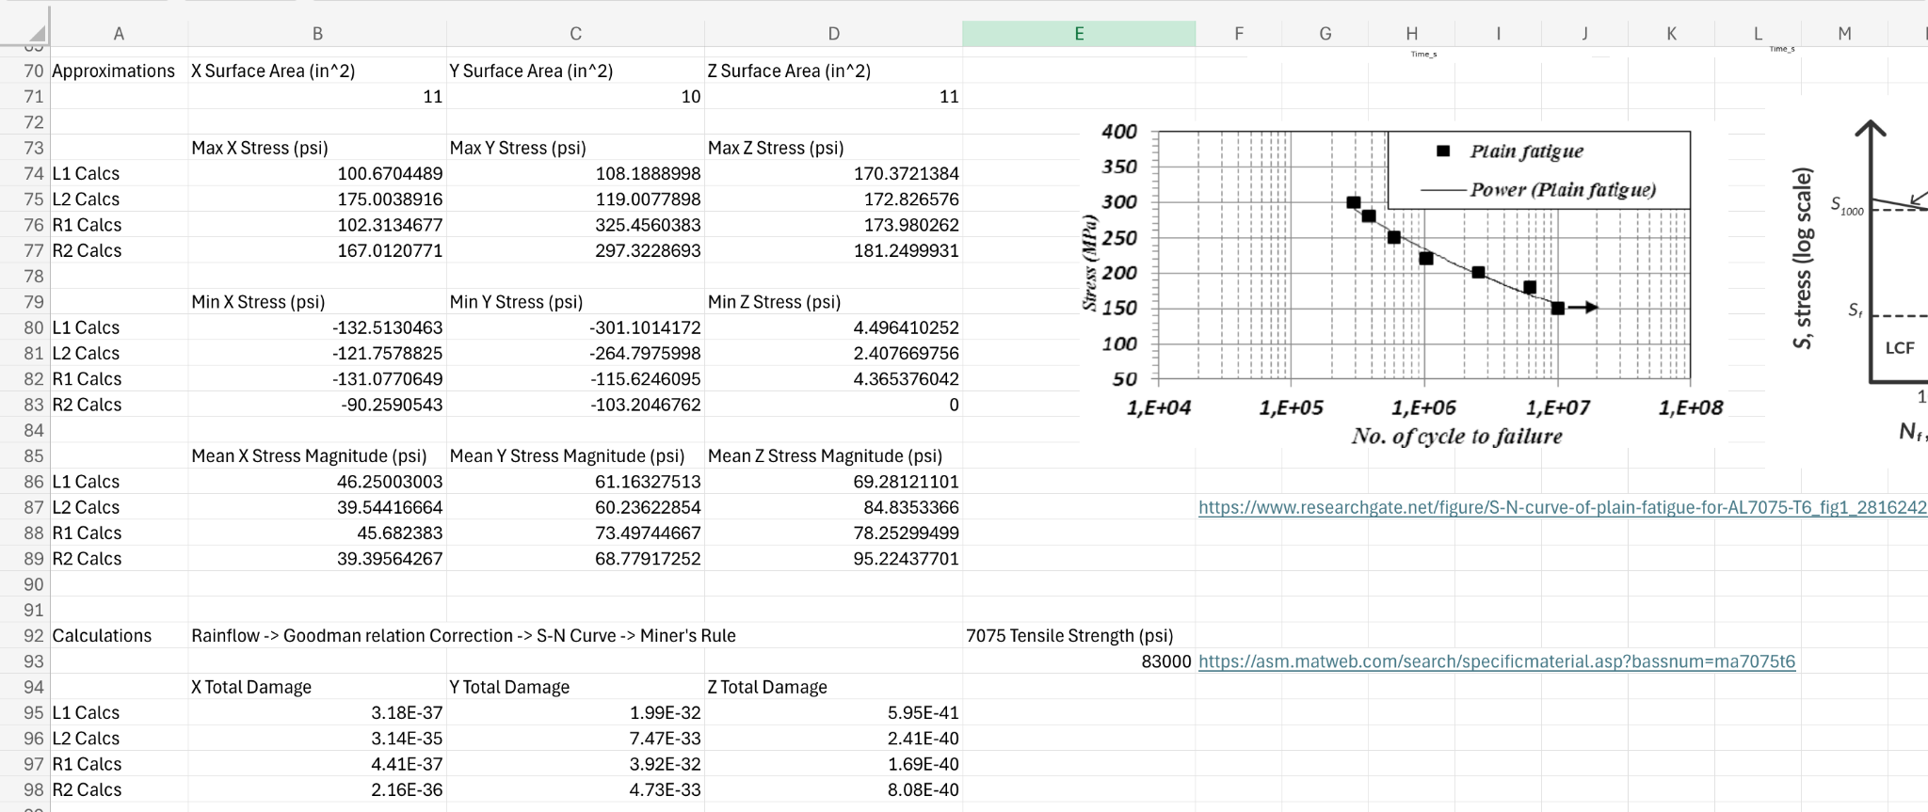
Fatigue Calculation
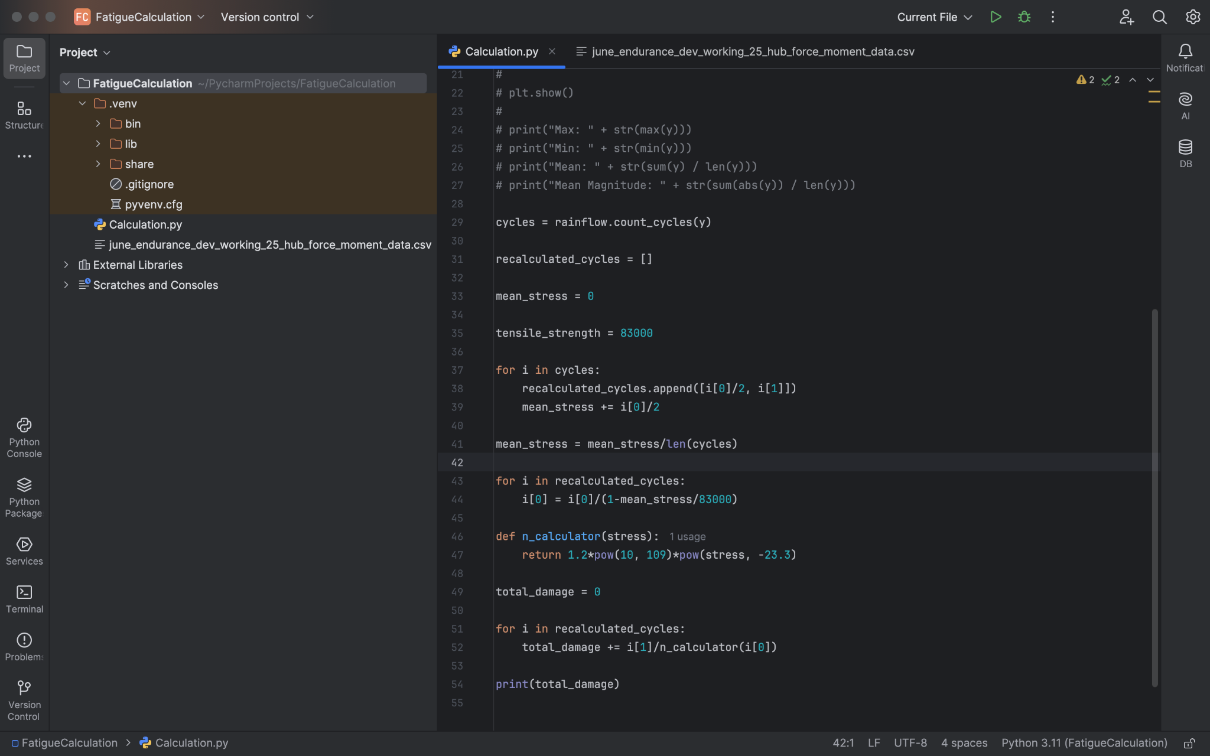
Python Fatigue Calculation Code
At last, I was also involved in designing and making drawings for the manufacturing jig of the A-arms. Since there are various angles between the A-arms and the inserts in different designs, a manufacturing jig is needed to assemble them efficiently. I designed the different towers for suspending the A-arms and the slanted towers for holding the A-arms. However, I later realized that I was supposed to use a top-down approach when designing the parts by referencing the assembly of the A-arms and the planes of the inserts, which was challenging for me due to configuration issues with Creo syncing. However, I was still able to make the engineering drawings after Derek made the CAD designs, specifically for the towers. I made the drawings using the IEM templates, and used the tolerances to highlight important dimensions that are most important to the precision of the manufacturing jig.
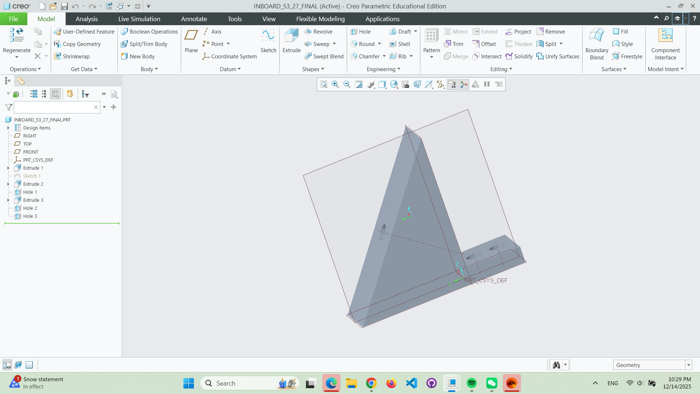
Sample of the CAD designs
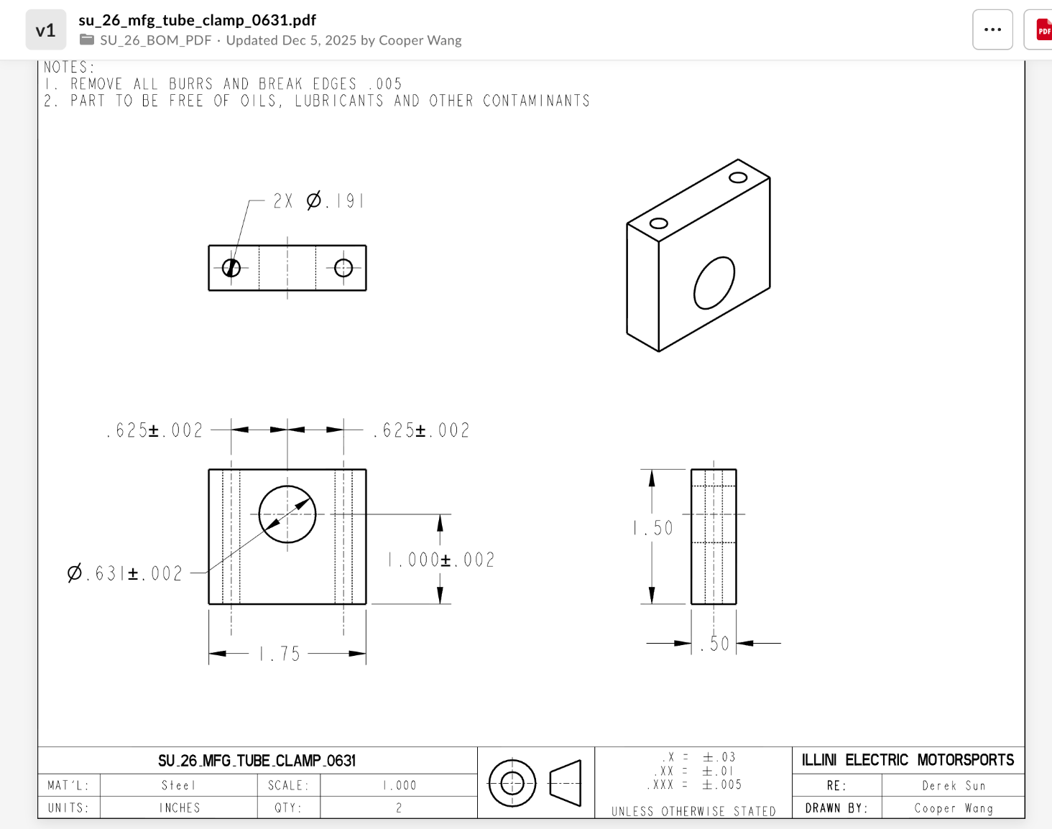
Sample of Engineering Drawing

